Ver. 3.14 3rd Edition Errata for Misbell Campaign 8/10/2005
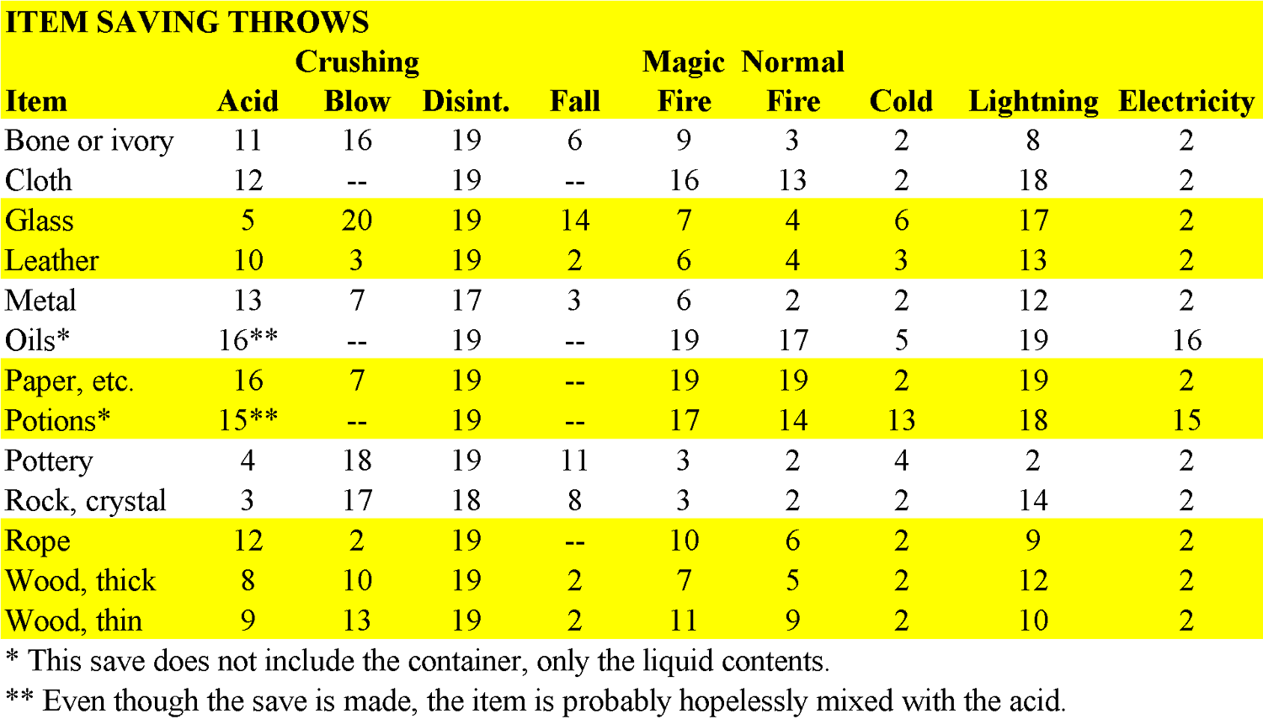
3rd Edition Characters
Experience Point Chart
Level Experience
2 2,000
3 4,000
4 8,000
5 16,000
6 32,000
7 64,000
8 125,000
9 250,000
10 +250,000 per
additional level

Classes:

Bard: At 5th level, and every 3rd level after that, bards can unlearn a single lower level spell (2 less than the maximum known) and learn another in its place.
Monk: (can use the Monk in 3.5)
The quarterstaff can also be used with the flurry of attacks
# of Stunning Attack per day=Monk Level+Wis bonus. Duration is 1d(level/3) rounds.
At 5th level, the Monk can use Spears & Polearms
Ki Strike (+1 at 6th level, +2 at 12th level, and +3 at 18th level)
Paladin: (can use the Paladin in 3.5)
With a successful Healing check (DC 15), the paladin can deliver just the correct amount of Lay on Hands (amount delivered must be declared ahead of time in case the check is failed).
Ranger: (recommend using the Ranger in 3.5)
Rogue: Sneak Attacks: Extra damage occurs if the rogue is directly behind that target (flanking) and the target is attacking someone else. Off-Hand attacks are not sneak attacks, but the thief still gets +2 to hit for flanking.
Sorcerer: Sorcerers gain a bonus Feat every 5 levels (5th, 10th, etc.) just as Wizards do. It must be a metamagic feat.
At 4th level, and every even level after that, sorcerers can unlearn a lower level spell (2 less than the maximum known) and learn another in its place.

Races: All can use racial weapons without the Exotic Weapon feat
Dwarf: Speed of 20' regardless of armor type worn

Feats: Many are available which are not in the book, watch the www.Misbell.com web page.
Combat Casting: always +4 to concentration (yes, better than Skill Focus, and they stack)
Endurance: can sleep in medium armor without suffering from fatigue
Magic Item Creation: We're not using the feats for this. It takes a high-level wizard, Enchant an Item, research & $.
Maximize Spell: Uses a spell +2 levels higher
Metamagic Feats: Since we do not use a 'fire-forget' system, these feats can be used on any spells memorized that day, they do not have to be selected when spells are memorized.
Weapon Finesse: A specific weapon does not need to be declared, it can be used for unarmed strike

Weapons:
If knocked out (-1 to -10 hp) by a blunt weapon, a Fortitude roll (DC 20) is allowed every round until raised to 1hp.
Shurikens are light, so within 20' get ½ Strength bonus to damage (as opposed to none in the 3.0 book)

Experience Points: Some powerful spells cost Experience Points. (Wish, Permanency, etc.) Because of the different XP chart we use, multiply these costs by 6 (so Wish is 30,000 XP). This is still half the equivalent cost on the official 3E chart.
Spells:
Concentration Check for Spell Casters before casting - DC = 0+damage taken+level of spell being cast (Treat activating items as 0-level)
Concentration Check for Spell Casters during casting - DC = 10+damage taken+level of spell being cast (Treat activating items as 0-level)
Casting a Spell One-Handed: this can be done for somantic spells with a Concentration Check of 15+spell level.

Casting Times for Buff spells (Dexterity/Endurance/Strength) is 10 minutes

Durations: 1 Round is 6 seconds.

Effects: Align Weapon: available to all Clerics
Call Lightning: dur 1min/level, up to 1bolt/round (max 1 bolt/level), 3d6/bolt (3d10 in a storm), medium range
Call Lightning Storm: available to all Druids
Color Spray: 15' range (correction)
Continual 'Flame': is still a ball of light if you want it to be.
Control Water: also a 4th level Druid spell
Creeping Doom: summons 1 swarm / 2 levels
Delayed Blast Fireball: 1d6+1 / level
Dictum/Blasphemy/Holy Word/Word of Chaos: can affect higher levels (categories: 'caster level', 'caster level -1', '-5', '-10')
Dimensional Lock: available to all Clerics
Divine Power: +6 Strength enhancement (instead of flat 18)
Find Traps: A Search Bonus is given, equal to ½ caster level
Glyph of Warding: there are still unique Glyphs available, ask for a sheet
Haste: Cannot be used to cast an extra spell in a round, +4 AC, +30 to speed (double speed maximum) OR an Extra Attack
Harm: Used offensively, does maximum of 10pts/level, Fortitude save for ½ Damage
Heal: Used offensively, does maximum of 10pts/level, Fortitude save for ½ Damage
Insect Plague: 1 swarm / 3 levels
Invisibility: Indirect hostilities DO end the spell.
Light (ranged): exists as a 1st level spell for all clerics
Mass Cures are available ('short range', 4 levels higher than individual spell)
Mass Heal: bumped up to 9th level
Negative Energy Protection: duration 10min / level
Neutralize Poison: duration 10min / level
Otto's Irresistible Dance: -10 to Reflex saves
Polymorph Self/Other: The maximum Strength, Dex, or AC change is +5, there is no Con change. Both can DECREASE as well.
Raise Dead/Resurrection: Character can choose to lose a level or a Con point. Drop to same % of previous level.
Regeneration: cures 4d8+caster level (instead of 1d8+)
Reincarnate: The 3.5 list is used.
Shield Spell: provides +4 Shield Bonus to AC, complete 360 coverage
Spiritual Weapon: +Wis bonus to hit, +1/3 caster level to damage
Summon Swarm: MAY prevent spellcasting, caster is allowed a Concentration Check of 15+damage taken that round
Teleport: remove 'description' row from table
Transmute Rock to Mud: Worked stone resists this spell with a DC of Caster's Level
Wall of Force: 1000gp material component extends duration to 1 minute per level

d% Incarnation Str Dex Con d% Incarnation Str Dex Con
01 bugbear +4 +2 +2 63-74 halfling -2 +2 +0
02-13 dwarf +0 +0 +2 75-89 human +0 +0 +0
14-25 elf +0 +2 -2 90-93 kobold -4 +2 -2
26 gnoll +4 +0 +2 94 lizardfolk +2 +0 +2
27-38 gnome -2 +0 +2 95-98 orc +4 +0 +0
39-42 goblin -2 +2 +0 99 troglodyte +0 -2 +4
43-52 half-elf +0 +0 +0 100 other ? ? ?
53-62 half-orc +2 +0 +0

